## Identifiers

### A name in Java Program is Identifiers

The below highlighted are identifiers

Class Test{

Public static void main (String[] args){

Int x=10;

}

}

1. To define an identifier You can use a to z or A to Z or 0 to 9 or $ or _
2. Identifier should not start with numeric Ex: 123total is invalid and total_123 is valid
3. Java is case sensitive programming language
   1. Int num=10;
   2. Int Num=10;
   3. Int NUM=10;
4. We cant use reserved words as identifiers.
   1. Int if=10; is invalid will give compile time error
5. All predefined java class names and interface names can be used as identifiers which is highly not recommended.

## Reserved Words

Reserved Words(53)

Keywords(50) Reserved Literals(3)

Used Keywords(48) Unused Keywords(2) – goto & const

1. if 1. True

2. else , etc… 2. false

3. null

Keywords for datatypes(8): byte, short, int, char, long, double, float, boolean

Keywords for flow control(11): if, else, switch, case, default, while, do, for, break, continue, return

Keywords for modifiers(11+1): public, private, protected, static, final, abstract, synchronized, native, strictfp(1.2v), transient, volatile,(default)

Keywords for exception handling(6): try, catch, finally, throw, throws, assert(1.4v)

Class related Keywords(6): class, Interface, extends, implements, package, import

Object related Keywords(4): new, intanceof, super, this

Void return type keyword(1) : void (in java return type is mandatory where in C language is optional)

Enum keyword(1) : enum(1.5v) – use enum to define a group of named constants

Ex: enum month{ jan, feb,…. ,dec}

## DataTypes

In java every variable should be of any type, no variable can be declared without the data type

Java language is strongly typed- type is important

Java is not considered as pure object oriented programming language because several oops featrures are not satisfied by java( like operator overloading and multiple inheritance , etc…)

Moreover we are depending on primitive datatypes which are non-objects

### Primitive DataTypes

#### 1.Numeric Datatypes

#### 2.Non-numeric Datatypes

Except Boolean and char all other primitives are signed datatypes

Floating datatypes – 2 types

1. Float(5-6 decimal places accuracy)- follows single precision
2. Double(14-15 decimal places accuracy) – follows double precision

Size & range is NA for Boolean. The size is virtual machine dependent.

Java is Unicode based(16 bytes in which first 256 characters are same as UNIcode values only) , c is ASCII based(8 bytes is enough <256)

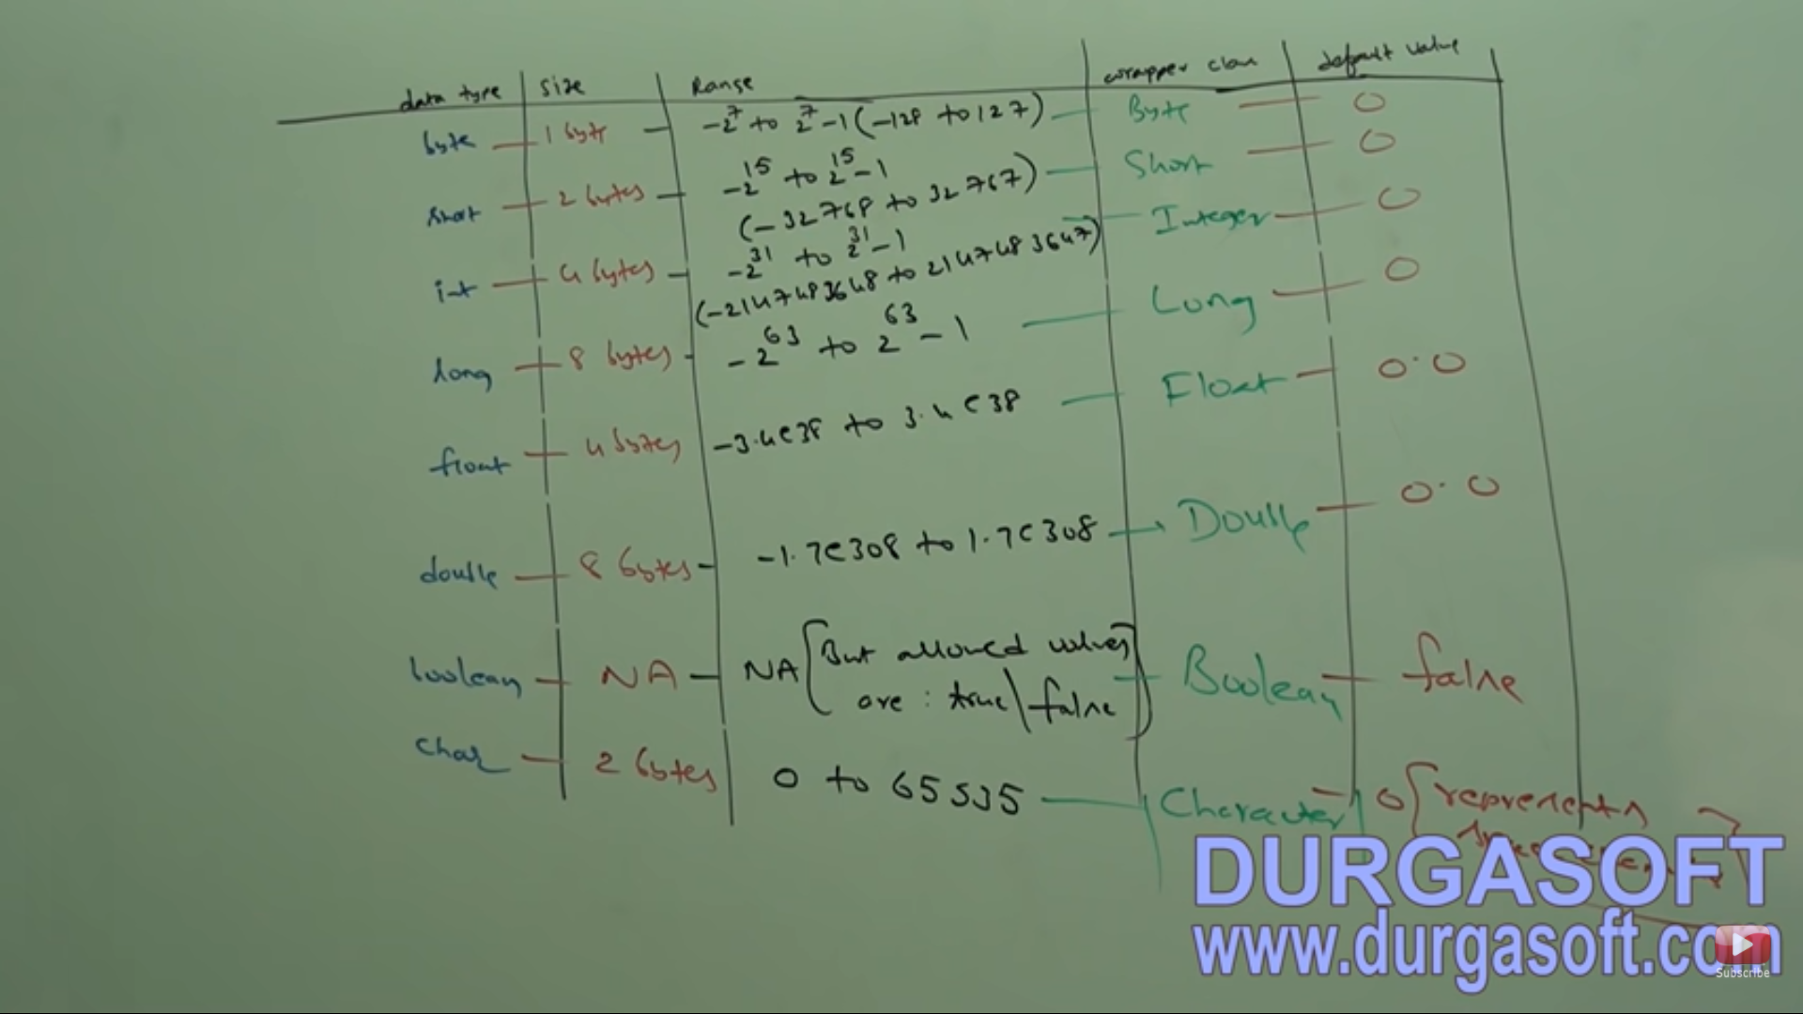

# Literals

Literal is a constant value that can be assigned to a variable.

Int x=10;

Int is datatype/keyword

X is name of variable/identifier

10 is constant value/literal

Types

1. Decimal Literal
2. Octal
3. Hexadecimal(you can use lower/upper case – one of few area where java is not case sensitive)

1.2e3 is 1200.00

Char literals can be ‘a’ or ‘\uoo12’ or 0 to 65535

Escape characters

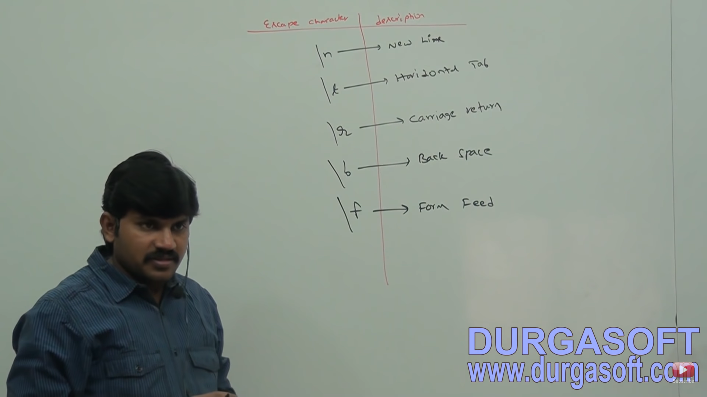

For int datatype until 1.6v we can specify literal value in the following ways

1. Decimal
2. Octa
3. HexaDecimal form

But from 1.7v onwards we can specify literal value even in binary form also. Allowed digits are 0 and 1.

Ex: 0b1110 , 0B1111

From 1.7v onwards we can use ‘_’ symbol between numeric literals.

Ex: double d=123_346_789_4.0 or 123346789( this is only for readability (ie. In .java files only) after compilation compiler will remove this ‘_’)

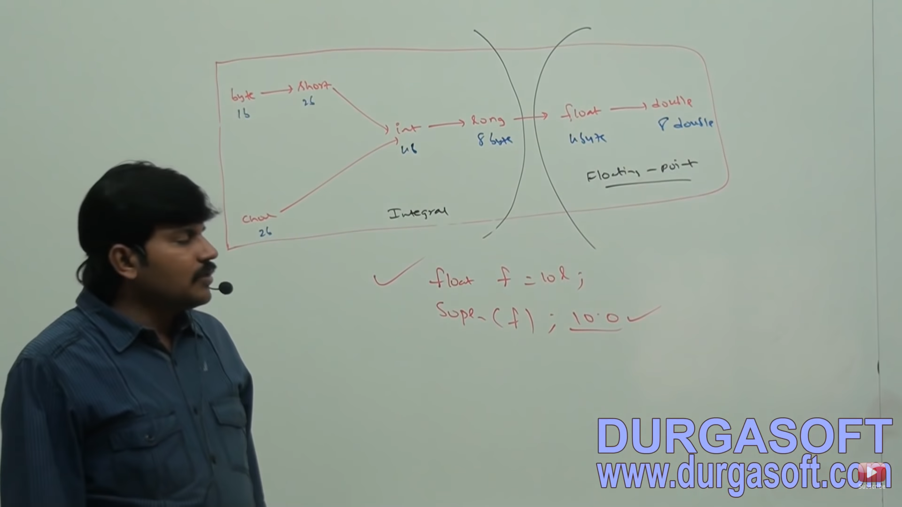

Memory representation is different internally for int and long.

# Arrays

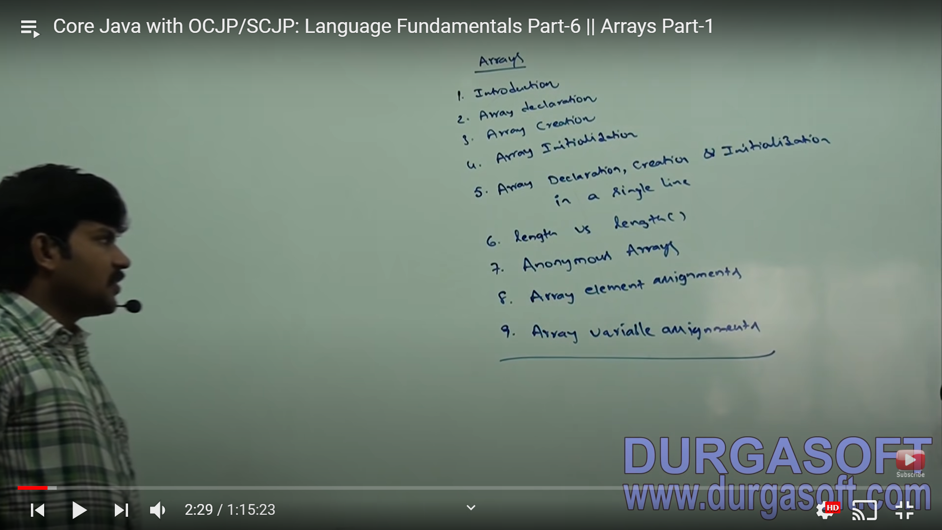

Array is an indexed collection of fixed number of homogeneous data elements

## One dimensional Array

Declaration : int x[] or int[] x or int []x middle is recommended since size is clearly separated from type

At the time of declaration we cant specify the size otherwise we will get compile time error.

Int[5] x; is invalid int[] x; is valid

Every array in Java is object only. Hence we can create arrays by new operator.

The array class are not available to the programmer level. Hence int array will be printed as [I

At the time of array creation we should compulsory provide size else we will get compile time error.

Array size allowed datatypes

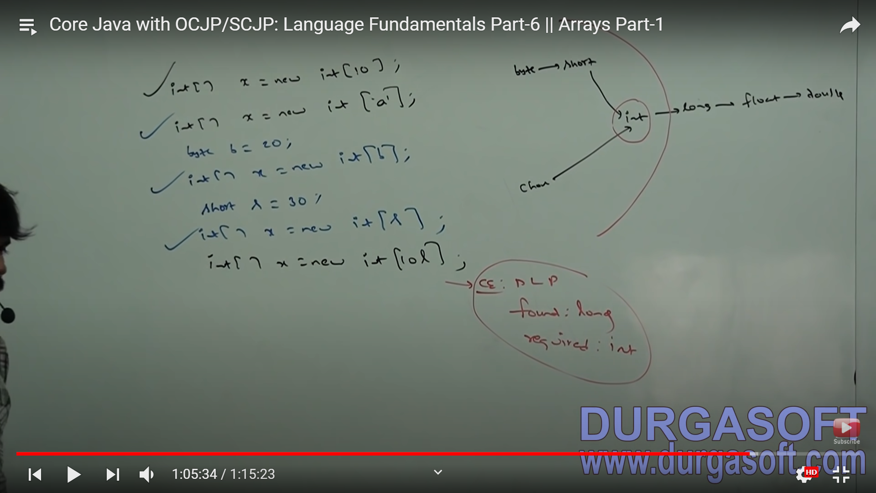

2d Array Creation:

In Java, 2d array not implemented by using matrix style implementation. They followed array of array approach for multidimensional array creation

Length is a final variable in array,

EX: int[] x=int[2];

2 is the length.

Length method ( length() )returns number of characters present in the String.

Arrays created for one-time use, instant use, without name are called anonymous arrays.

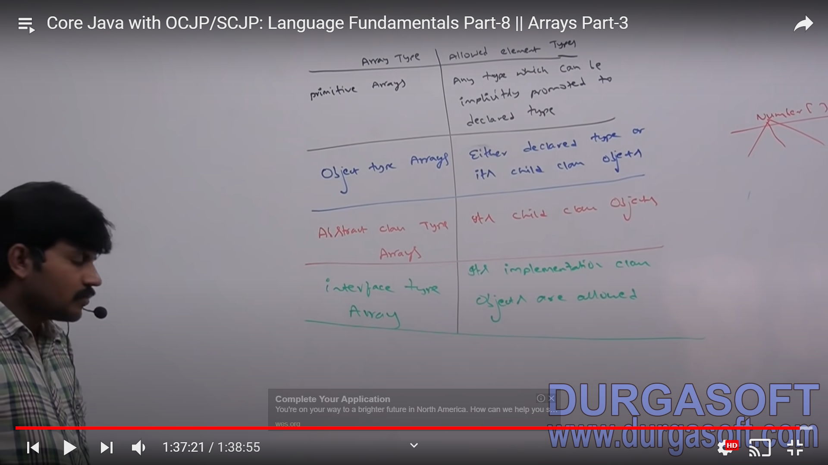

Element level promotions not applicable at array level.

Char element to int is possible but char array to int array is not possible.

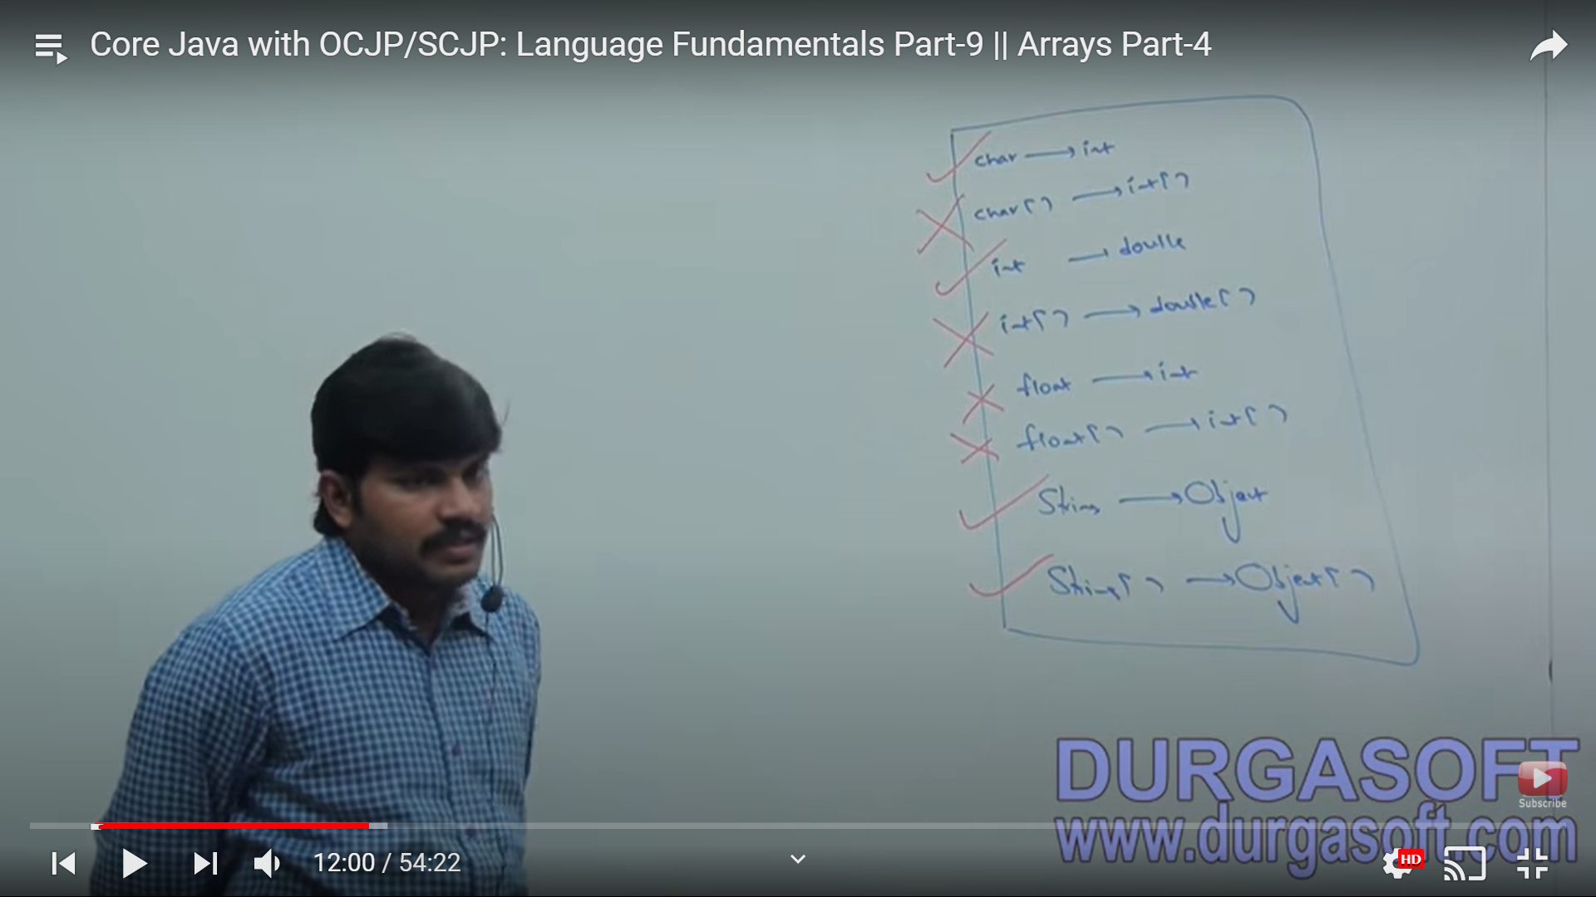

When you assign one array variable to another , internal elements will not be copied only reference variable will be reassigned.

Array Declaration, Creation & Initialization: